Experiment 2:
Aim: To containerise the application using docker
This experiment maps to LO4.
LO4: Containerize, orchestrate, and deploy applications using Docker, Docker Compose, Kubernetes, and cloud infrastructure tools.
Theory:
Docker is an open-source containerization platform that enables applications to run in isolated environments called containers. A container includes the application along with all its required libraries, dependencies, and configuration files, ensuring consistent execution across different systems. Since containers share the host operating system's kernel, they are lightweight, portable, and start much faster than traditional virtual machines.
A Docker image is a read-only template that contains everything needed to create a container, including the operating system, software packages, and application files. Images are stored in repositories such as Docker Hub and can be downloaded using the docker pull command. Once an image is available locally, it can be used to create one or more containers.
Docker provides several commands for managing images and containers. The docker --version command is used to verify the installed Docker version, while docker images display all locally available Docker images. The docker search command allows users to search Docker Hub for official or community-maintained images, and docker pull downloads the required image from the repository.
Containers are created and started using the docker run command. Running a container interactively (docker run -it ubuntu) opens a Linux shell inside the container, allowing users to execute Linux commands as if they were working on a standalone Ubuntu system. Commands such as pwd display the current working directory, ls lists the files and directories, mkdir creates a new directory, cd changes the current directory, touch creates an empty file, echo writes text into a file, and cat displays the contents of the file.
These basic Docker and Linux commands help users understand how containers work, how to interact with a running container, and how to perform file and directory operations within an isolated environment. This forms the foundation for deploying, testing, and managing applications using Docker in real-world DevOps workflows.
Docker Installation Steps
- Check system requirements: Ensure your operating system supports Docker and virtualization.
- Enable virtualization (Windows): Turn on Intel VT-x or AMD-V in the BIOS/UEFI settings.
- Install WSL 2 (Windows only): WSL 2 provides the Linux environment required by Docker Desktop.
- Download and install Docker Desktop: Install Docker Desktop from the official Docker website and follow the setup instructions.
- Restart your computer: Restart if prompted to complete the installation.
- Launch Docker Desktop: Open Docker Desktop and wait for the Docker Engine to start.

What is a docker image?
A Docker image is a read-only template used to create Docker containers. It contains everything required to run an application, including the operating system, application code, libraries, dependencies, configuration files, and runtime environment. Docker images are stored in repositories such as Docker Hub and can be downloaded using the docker pull command. Since images are portable and platform-independent, they ensure that applications run consistently across different environments.
A Docker image itself cannot execute applications. When the docker run command is used, Docker creates a container, which is a running instance of the image. Multiple containers can be created from the same image, making Docker an efficient solution for application deployment, testing, and scaling. Images are also built in layers, which reduces storage requirements and speeds up image downloads and updates by reusing common layers.
What is containerization?
Containerization is a virtualization technology that packages an application along with all its dependencies, libraries, configuration files, and runtime environment into a single, isolated unit called a container. This ensures that the application runs consistently across different environments, regardless of the underlying operating system or hardware.
Unlike traditional virtual machines, containers share the host operating system's kernel, making them lightweight, fast, and resource-efficient. Containers start within seconds, require less memory, and allow multiple applications to run independently on the same system without conflicts. Docker is one of the most widely used platforms for containerization, enabling developers to build, deploy, and manage applications efficiently. Containerization improves application portability, scalability, and reliability, making it an essential technology in modern software development and DevOps practices.
What is the difference between docker image and docker container?
Docker Image | Docker Container
A read-only template used to create containers. | A running instance of a Docker image.
Contains application code, libraries, dependencies, and configuration files. | Contains the running application along with its processes and data.
Cannot execute applications by itself. | Executes the application inside an isolated environment.
Created using a Dockerfile. | Created using the docker run command.
Stored in image repositories such as Docker Hub. | Exists only while it is created on the host system.
Multiple containers can be created from a single image. | Each container is an independent instance of the image.
Read-only and cannot be modified directly. | Read-write; changes can be made while the container is running.
Example: ubuntu, nginx, python, mysql images. | Example: A running Ubuntu container created using docker run -it ubuntu.

Implementation:
1)check docker version
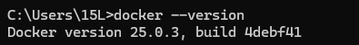
2)images
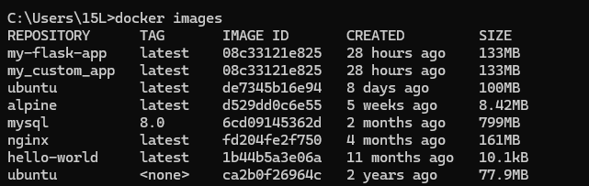
3)
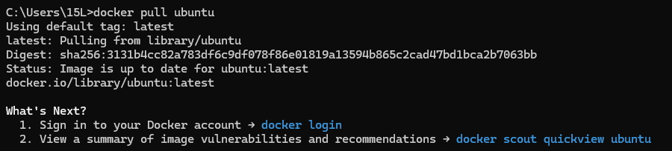
4)
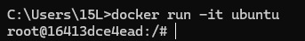
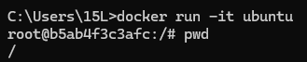
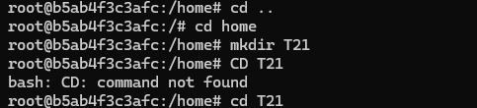
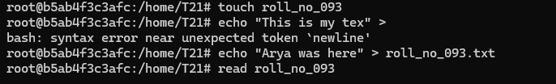
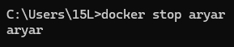
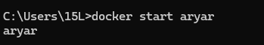
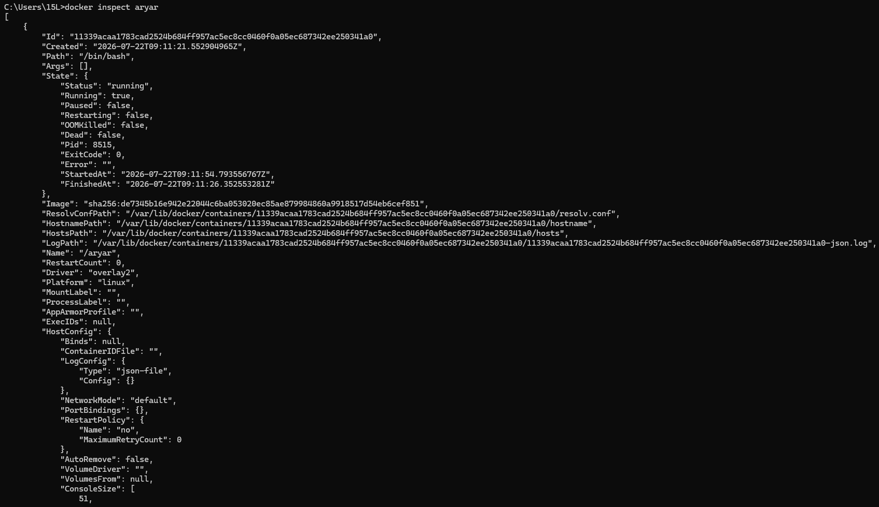

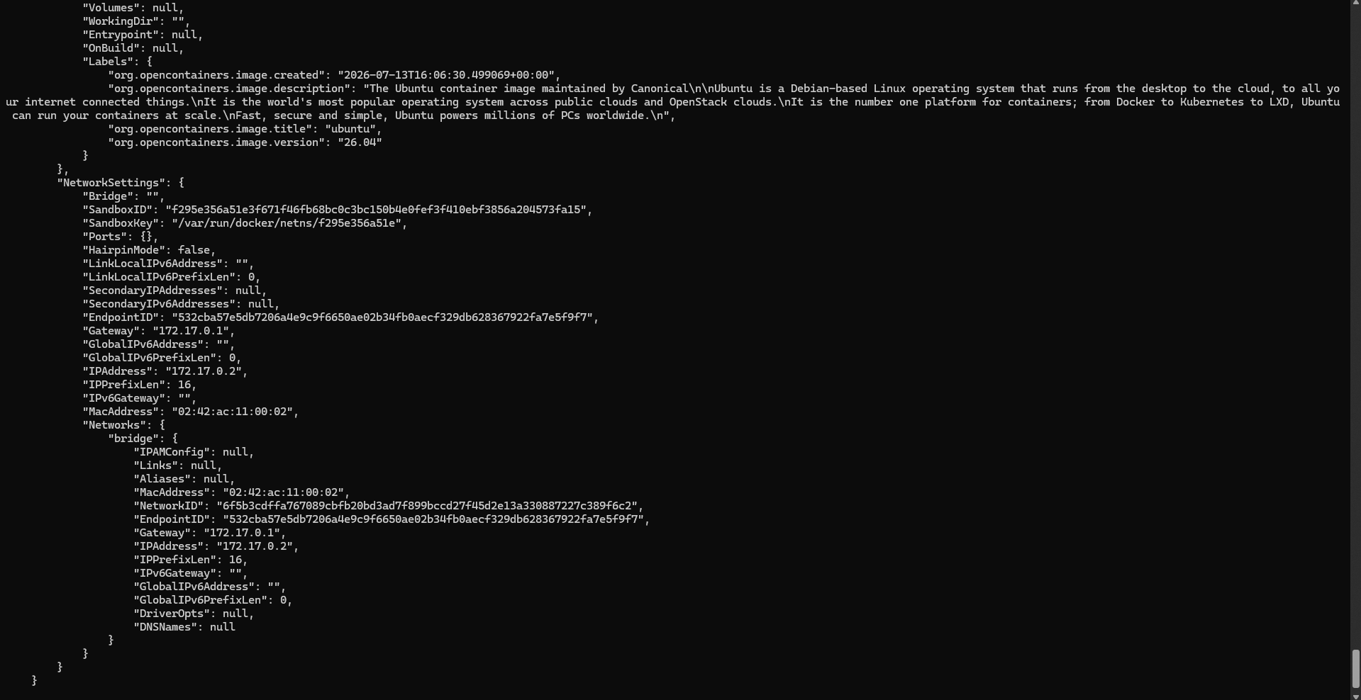
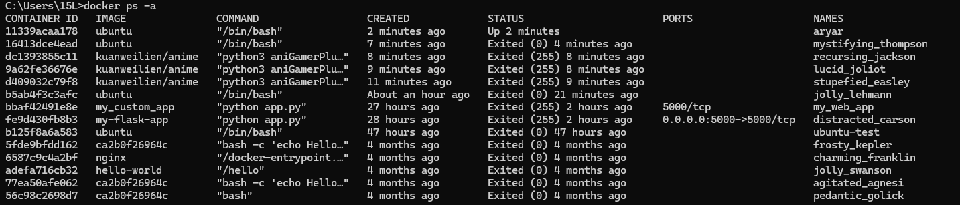
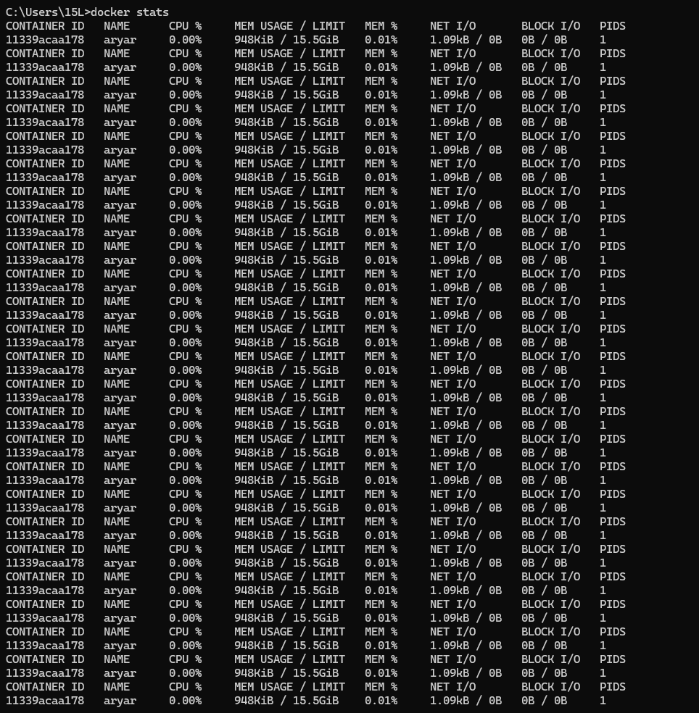
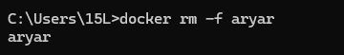
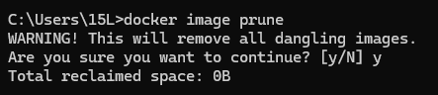
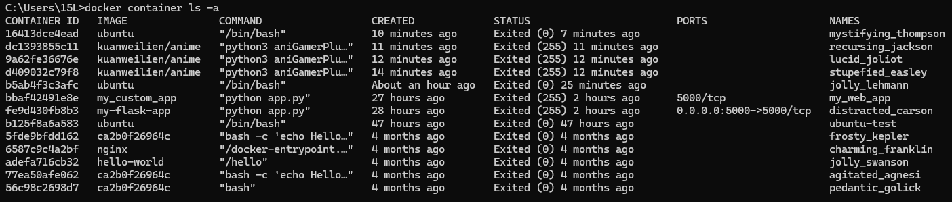
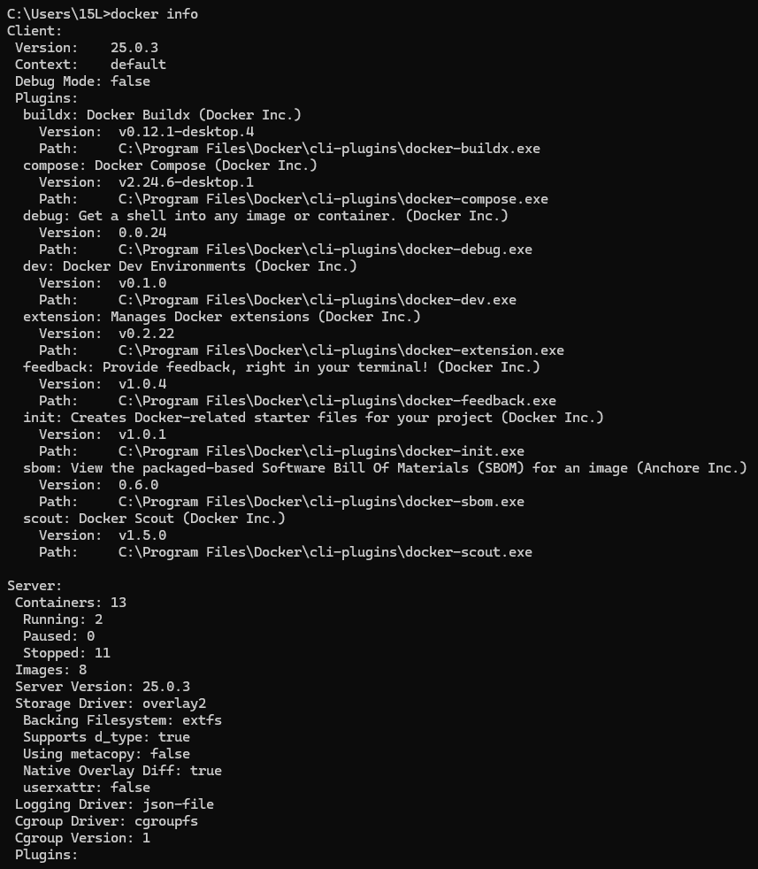
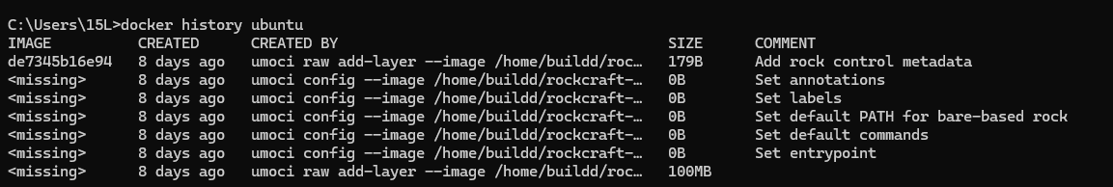
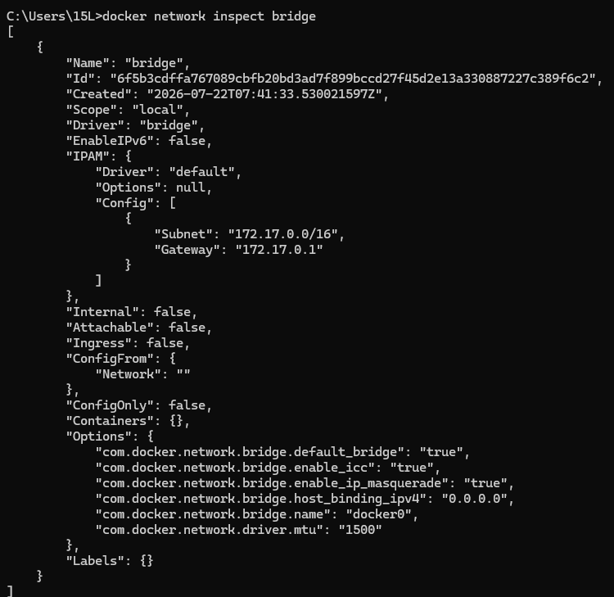

Conclusion:
In this experiment, we learned the fundamentals of Docker by performing basic image and container operations. We verified the Docker installation, searched for and downloaded Docker images from Docker Hub, listed locally available images, and created an Ubuntu container using a Docker image. Inside the container, we executed basic Linux commands to navigate directories, create folders and files, write data to a file, and verify its contents. This experiment helped us understand the concepts of Docker images, containers, and containerization, as well as how Docker provides an isolated and consistent environment for running applications efficiently.

